A Case Study in Renal Physiology
and Acid-Base Balance

Part I – At the Hospital
“Something is wrong. My mother is sick and very disoriented,” explained Bobby, a middle-aged man, who was looking very anxious as he spoke with staff in the Emergency Department (ED) where he had brought his mother, Arlene Burroughs, an 83-year-old white woman.
Table 1. Grandma’s Test Results
Serumcreatinine=8.3mg/dL

BUN(bloodureanitrogen)=55mg/dL
Serumcalcium(total)=15.76mg/dL
Serumsodium=128mEq/L
Serumpotassium=2.7mEq/L
Serumbicarbonate(venous)>40mEq/L
SerumpH(venous)=7.67
Urinarypotassium=45mEq/L

“She’s disoriented and lethargic, and she has been vomiting and complaining of an upset stomach,” he said to the triage nurse who examined Mrs. Burroughs. The nurse noted that Mrs. Burroughs did not have a fever or any other signs of infection but that she did appear to be dehydrated.
The attending physician in the ED ordered a battery of tests. “I’m especially concerned about her kidney function,” he told Bobby.

I don’t understand, said Bobby. Shouldn’t you be looking at her brain? That seems to be where the problem is! She is really confused,and doesn’t that tell you that something is wrong with her brain function? What if she’s had a stroke?

“Well, she certainly may be having some problems, but her brain and nerves may be responding to changes that are produced by her kidneys,” the doctor explained. “Let’s get some more information so we’ll know where to look for the problem.”
The results of these tests are provided in Table 1. Table 2 provides normal ranges of values for standard laboratory tests.
Table 2: Selected Normal Laboratory Values
Blood Gases
 | Arterial | Venous
pH | 7.35-7.45 | 7.32-7.42
pCO2 (mmHg) | 35 – 45 | 38 – 52
pO2 (mmHg) | 70 – 100 | 28 – 48
HCO3 (mEq/L) | 19 – 25 | 19 – 25
O2 Sat % | 90 – 95 | 40 – 70
Kidney Function Test
BUN (blood urea nitrogen) | 7 – 20 mg/dL
Serum Creatinine | 0.5 – 1.4 mg/dL
Electrolytes
Calcium | 8.8 –10.3 mg/dL
Calcium, ionized | 2.24 – 2.46 mEq/L
Chloride | 95 – 107 mEq/L
Magnesium | 1.6 – 2.4 mEq/L
Phosphate | 2.5 – 4.5 mEq/L
Potassium | 3.5 – 5.2 mEq/L
Sodium | 135 – 147 mEq/L

Part II – What Else Do We Know About the Patient?

Bobby handed the physician a paper bag with several bottles in it. “These were on Mom’s kitchen table,” he said. “I just don’t understand—she’s very good about taking her medicine.”
In the bag is a bottle of hydrochlorothiazide (25mg), a prescription medicine used to lower blood pressure. The label on the bottle reads, “Take one capsule in the morning and one capsule in the evening.”
“Mom calls these her ‘water pills.” She complains that they make her use the restroom more often.
Also, in the bag were a bottle of TumsUltra 1000mg (CaCO3) and Alka-Seltzer(NaHCO3).“Do you know how often your mother takes the Alka-Seltzer?” the doctor asked Bobby. “Or how many Tums?”“Oh, I’m not sure. I can’t be with her all day, and she lives alone. We take turns checking on her, me, my daughter, and my brother’s family. But I don’t understand why you need to know about these,” replied Bobby, looking closely at the bottle of brightly colored tablets. “We buy them at the grocery store, it’s not like they’re medicine, or anything.”
Just then, Mr. Burroughs’ daughter, Charlotte, entered the examination room. Charlotte was a biology major in college. “I came as fast as I could,” she added,” but traffic from school was a bear. What’s wrong with Granny?”
“We were just looking at your grandmother’s medicines,” said the doctor. Your father was trying to give me some more information, so we can figure out what’s causing her problems. Do you know anything about the Alka-Seltzer or the Tums he found on her kitchen table?Charlotte looked at the physician and her dad. “Granny was taking the Alka-Seltzer this week because she was complaining about an ulcer. She said this was how they used to treat them when she was a girl. She always took it when I was there. I think she was drinking a lot of milk lately, too, and she said it was good for her stomach. And she always took the Tums because they are supposed to be good for your bones, right? I think she took those twice a day.”
“Now that you mention it,” Bobby chimed in, “she took the Alka-Seltzer every time I was there too. I think she’s finished about two gallons of milk just this week, which is surprising since she usually doesn’t like milk. I always thought it was sort of funny that she didn’t like the taste of milk even though she grew up on a dairy farm.”
“Hmmmm, I think we’d better see what her parathyroid hormone levels are,” the physician said. “I’ll have those measurements made right away. I’ve got a hunch that we’ll find there is more wrong with her kidneys than we thought before.”
An alarm went off on his pager. “Excuse me for just a minute—I need to check on another patient before she goes home. Don’t go away and don’t worry—your mother is in excellent hands.”

Part III – PTH Levels
Bobby and Charlotte were with Mrs. Burroughs’ in her room. She had been admitted to the hospital and was receiving intravenous fluids. She seemed to be feeling better and was less confused. At the moment, she was sitting up in bed, chatting a bit and napping intermittently.
The physician knocked at the door. “How is everyone? Mrs.Burroughs, how are you feeling?Better, thank you,” replied Mrs. Burroughs. “My stomach doesn’t seem to hurt as much. ShouldI take my Tumsnow? I don’t want to fall and break a hip! And it’s really about time for a glass of milk.”Oh, I don’t think there’s much danger of falling here. In fact, I don’t think you should be taking either the Alka- Seltzer or the Tums, since I think that’s what caused the problem, said the doctor. It looks like your serum PTH is 8mg/dL, about what I expected. This tells me that the antacids may have altered your kidney function, and that’s how you ended up in here.”
So, she’s sick now because of the Tums asked Bobby, incredulously. Why do they sell those things if they make people sick?Well, I think she’s sick now because maybe she took too many Tumsand the Alka-Seltzer, replied Charlotte.But I thought that the kidney would just eliminate anything that the body can’t use, if it’s water-soluble of course. I don’t understand why her body didn’t protect her from that, if it was dangerous.”Your daughter is on the right track,” said the physician. The kidney is responsible for regulating the amount of every substance in the body’s internal environment. Your mother has got two main problems: too much calcium and too little acid.

Mrs. Burroughs’s serum calcium level is higher than normal,which indicate her blood can weaken her bones and kidney stones. According to Myso clinic, hypercalcemia can cause stomach upset, nausea, vomiting and constipation, which what Mrs. Burroughs suffering. Moreover, the weaken muscle activity and kidney function also affect her abnormal serum creatinine, because creatinine is a waste product in the blood that comes from muscle activity. So, when the muscle activity and kidney function slow down, the creatinine level rises above normal. In additional, with kidney function slow down, it also rises blood urea nitrogen to above normal levels.

Part IV – What about the Calcium?

Oh, I see it now! All her symptoms are due to her kidneys not working well, so the pH and concentrations ofions were not right in her body, said Charlotte. See, the important chemical reaction is this one, she added as she wrote this on a piece of paper:
CO2 + H2O ⇄H2CO3 ⇄ H⁺ + HCO3⁻

This reaction shows why carbonic acid, H2CO3, works as a buffer. We are learning about this in my biochemistry class at school. It can tie up H⁺ ions when there are too many, or it can produce more H+ ions when there are too few. This keeps the concentration of H+ and pH relatively constant.

The kidney regulates the concentration of HCO3⁻ by preventing its loss in the kidney tubules. It can also secrete HCO₃⁻ into the kidney tubule when there is too much in the body. It also shows how the lungs and the kidneys work together to regulate pH in the body, said the physician. CO2 is a gas, remember? The lungs, well really the brain and nervous system, can change the amount of CO2 present in the body by changing respiratory rate.

Alright, I understand about the pH being too high. Granny would not have developed this if she had not taken all those antacid tablets. But I don’t understand why her calcium levels are so high? And, she had osteoporosis—shouldn’t any calcium she took be incorporated into her bones? Charlotte asked.
Wait a minute, I’m not understanding. Is there a problem with her breathing now? exclaimed Bobby.
Well, regulation of calcium also involves some kidney mechanisms, the physician replied, holding up a hand to deflect Bobby’s question for a minute. Let me draw adiagram that shows how calcium is reabsorbed from the kidney,specifically the distal convoluted tubule, you might be able to see some of the other things that can alter it. PTH also works here to stimulate calcium reabsorption from the kidney tubule, in addition to promoting its absorption from the digestive tract.
The physician drew the diagramon a piece of paper. This represents the distal convoluted tubule, or DCT, which is ‘downstream,’ or distal to the PCT in the nephron. I’m only showing some of the pertinent calcium pathways here, but you should know that kidney function is complex. We’re learning more about it all the time.”

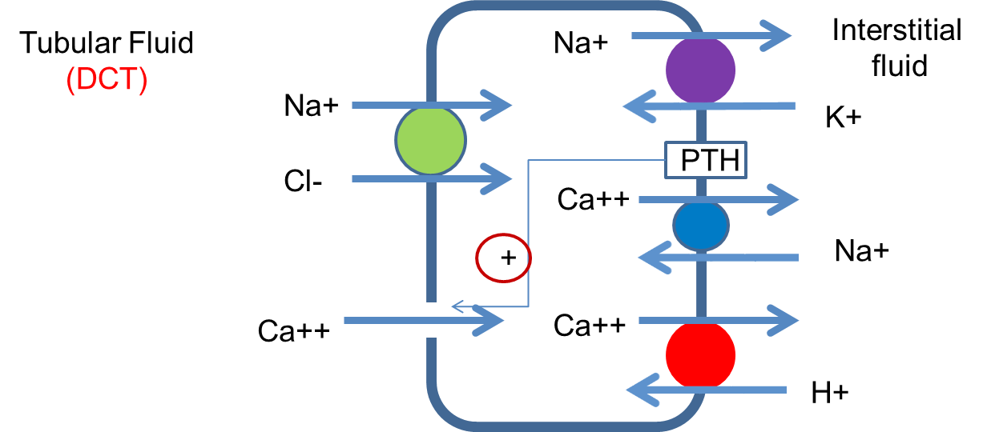

Figure 2. Distal convoluted tubule (DCT). Adapted from: Ives, H.E. (2012) Diuretic Agents. In B.G. Katzung, S.B. Masters, and A.J. Trevor (eds.) Basic and Clinical Pharmacology (p. 254). New York: McGraw-Hill.

Here, you should be able to see that reabsorption of calcium is very dependent on sodium movement acrossthe cell membranes. So, anything that changes the movement of sodium across a cell membrane would also be expected to change the movement of calcium.Just as an example—your grandmother is taking a thiazide diuretic. These medications work right here, in the DCT, to inhibit the reabsorption of sodium and chloride from the tubular fluid. You should be able to see how they can promote both hypercalcemia and alkalosis in someone like her.
And, no, there’s not a problem with her breathing. Although the respiratory system can respond quickly, it can’tcompletely overcome the problems in her kidneys.

